Features of Python Packages:
- Numpy
Numpy stands for Numerical Python. Numpy is an open-source library for the python programming language. It is used for scientific computing and working with arrays. The source code for Numpy is located at this github repository https://github.com/numpy/numpy.

Features:
  - High-performance N-dimensional array object.
  - It contains tools for integrating code from c/c++ and Fortran.
  - It contains a multidimensional container for generic data.
  - Additional linear algebra, Fourier transform and random number capabilities.
  - It consists of broadcasting functions.
  - It has data type capability to work with varied databases.

Scipy
Scipy stands for Scientific python. Scipy is a scientific computation library that uses Numpy underneath. The source code for Scipy is located at this github repository https://github.com/scipy/scipy.

Features:
  - Scipy provides algorithm for optimization, integration, interpolation, eigenvalue problems, algebraic equation, differential equations, statistics and many other classes of
problems.
  - It provides more utility functions for optimization, stats and signal processing.

Numpy Vs Scipy
Numpy and Scipy both are used for mathematical and numerical analysis. Numpy is suitable for basic operations such as sorting, indexing and many more because it contains array data, wherasscipy consists of all numeric data.
Numpy contains many functions that are used to resolve the linear algebra, Fourier Transforms, etc., whereas Scipy contains full featured version of the linear algebra module as well many other numerical algorithms.

Pandas
Python pandas is defined as an open-source library that provides high performance data manipulation in python. The name of pandas is derived from the word Panel Data, which means an Econometrics from Multidimensional data. It is used for data analysis in Python. Pandas is built on top of the numpy package, means numpy is required for operating pandas.

Features:
  - Group by data for aggregations and transformations.
  - It has a fast and efficient DataFrame object with the default and customizing indexing.
  - Used for reshaping and pivoting of data sets.
  - It is used for data alignment and integration of the missing data.
  - Provides the functionality of time series.
  - Process a variety of data sets in different formats like matrix data, tabular heterogeneous, time series.
  - Handle multiple operations of the data sets such as subsetting, slicing, filtering, groupby, re-ordering and re-shaping.

Statsmodels
Statsmodels is a python module that provides classes and functions for the estimation of
many different statistical methods as well as for conducting statistical tests and statistical data explorations. The package is released under the open source Modified BSD(3-clause) license. The online documentation is hosted at statsmodels.org.

Features:
  - Linear regression models like Ordinary least squares, Generalized least squares, Weighted least squares, Least squares with autoregressive errors.
  - Bayesian Mixed GLM for Binomial and Poisson
  - GEE: Generalized Estimating Equations for one-way clustered or longitudinal data
  - Nonparametric statistics: Univariate and Bivariate kernel density estimators
  - Datasets: Datasets used for examples and in testing
  - Sandbox: Statsmodels contains a Sandbox folder with code in various stages of development and testing.

Jupyter
A scientific approach requires the fast experimentation of different hypotheses in a reproductible fashion. Initially named IPython and limited to working only with the python language, Jupyter was created to address the need for an interactive command shell for several languages (based on the shell, web browser and application interface), featuring graphical integration, customizable commands, rich history (in the JSON format) and computational parallelism for enhanced performance.
Steps to install Jupyter using Anaconda
- Launch Anaconda Navigator
- Click on the Install Jupyter Notebook Button

Result:
Thus the anaconda software has been successfully installed and features of Numpy, Scipy, Jupyter, statsmodels and pandas packages has been explored.

Ex. No.: 1 | Working with Numpy Arrays

Aim:
To write a Numpy arrays program to demonstrate the basic array concepts in Jupyter
Notebook.

Algorithm:
Step 1: Start the program.
Step 2: Import the Numpy library.
Step 3: Define the 1-D array, 2-D array, 3-D array.
Step 4: Print the memory address, the shape, the datatype and perform some basic operations. Step 5: Then create an array using built-in Numpy functions and perform some mathematical functions.
Step 6: Print the output.
Step 7: Stop the program.

Program:
- NumPy program to print the NumPy version in your system. Code:
import numpy as np print(np.version) Output:
1.21.5

Numpy program to print different types of arrays.
#one-dimensional array

Code:
import numpy as np x=np.arange(2,6).reshape(4) print(x)

Output:
[2, 3, 4, 5]
#two-dimensional array

Code:
import numpy as np x=np.arange(2,10).reshape(2,4) print(x)

Output:
[[2 3 4 5]
[6 7 8 9]]
#three-dimensional array

Code:
import numpy as np x=np.arange(24).reshape(4,3,2) print(x)

Output:
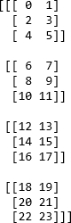

Numpy program to perform Array slicing. Code:
import numpy as np arr=np.array([1,2,3,4])
print(arr[1:3:2])
print(arr[:3])
print(arr[::2])

Output:
[2]
[1 2 3]
[1 3]

Numpy program to perform trigonometric functions. Code:
import numpy as np arr=np.array([0,30,60,90]) print(np.sin(arr)) print(np.cos(arr)) print(np.tan(arr)) Output:
[ 0. -0.98803162 -0.30481062 0.89399666]
[ 1. 0.15425145 -0.95241298 -0.44807362]
[ 0. -6.4053312 0.32004039 -1.99520041]

NumPy program to convert a list of numeric value into a one-dimensional NumPy array.
Code:
import numpy as np
l = [12.23, 13.32, 100, 36.32]

print("Original List:",l) a = np.array(l)
print("One-dimensional NumPy array: ",a)

Output:
Original List: [12.23, 13.32, 100, 36.32]
One-dimensional NumPy array: [ 12.23 13.32 100. 36.32]

NumPy program to create an array with values ranging from 12 to 38. Code:
import numpy as np x = np.arange(12, 38) print(x)

Output:
[12 13 14 15 16 17 18 19 20 21 22 23 24 25 26 27 28 29 30 31 32 33 34 35 36 37]

NumPy program to reverse an array (first element becomes last). Code:
import numpy as np import numpy as np x = np.arange(12, 38)
print("Original array:") print(x)
print("Reverse array:") x = x[::-1]
print(x)

Output:
Original array:
[12 13 14 15 16 17 18 19 20 21 22 23 24 25 26 27 28 29 30 31 32 33 34 35 36 37]
Reverse array:
[37 36 35 34 33 32 31 30 29 28 27 26 25 24 23 22 21 20 19 18 17 16 15 14 13 12]

NumPy program to append values to the end of an array. Code:
import numpy as np x = [10, 20, 30]
print("Original array:") print(x)
x = np.append(x, [[40, 50, 60], [70, 80, 90]])
print("After append values to the end of the array:") print(x)

Output:
Original array:
[10, 20, 30]
After append values to the end of the array:
[10 20 30 40 50 60 70 80 90]

NumPy program to find common values between two arrays. Code:
import numpy as np
array1 = np.array([0, 10, 20, 40, 60]) print("Array1: ",array1)
array2 = [10, 30, 40]
print("Array2: ",array2)
print("Common values between two arrays:") print(np.intersect1d(array1, array2)) Output:
Array1: [ 0 10 20 40 60]
Array2: [10, 30, 40]
Common values between two arrays: [10 40]

NumPy program to find the union of two arrays. Code:
import numpy as np
array1 = np.array([0, 10, 20, 40, 60, 80]) print("Array1: ",array1)
array2 = [10, 30, 40, 50, 70]
print("Array2: ",array2)
print("Unique sorted array of values that are in either of the two input arrays:") print(np.union1d(array1, array2))

Output:
Array1: [ 0 10 20 40 60 80]
Array2: [10, 30, 40, 50, 70]
Unique sorted array of values that are in either of the two input arrays: [ 0 10 20 30 40 50 60 70
80]

NumPy program to concatenate two 2-dimensional arrays. Code:
import numpy as np
a = np.array([[0, 1, 3], [5, 7, 9]])
b = np.array([[0, 2, 4], [6, 8, 10]])
c = np.concatenate((a, b), 1) print(c)

Output:
[[ 0 1 3 0 2 4]
[ 5 7 9 6 8 10]]

Write a NumPy program to convert the values of Centigrade degrees into Fahrenheit degrees and vice versa.
#Fahrenheit degree to Centigrade degree.

Code:

import numpy as np
fvalues = [0, 12, 45.21, 34, 99.91, 32]
F = np.array(fvalues)
print("Values in Fahrenheit degrees:") print(F)
print("Values in Centigrade degrees:") print(np.round((5*F/9 - 5*32/9),2)) Output:
Values in Fahrenheit degrees:
[ 0. 12. 45.21 34. 99.91 32. ]
Values in Centigrade degrees:
[-17.78 -11.11 7.34 1.11 37.73 0. ]
#Centigrade degree to Fahrenheit degree.

Code:
import numpy as np
cvalues = [-17.78, -11.11, 7.34, 1.11, 37.73, 0]
C = np.array(cvalues)
print("Values in Centigrade degrees:") print(C)
print("Values in Fahrenheit degrees:") print(np.round((9*C/5 + 32),2)) Output:
Values in Centigrade degrees:
[-17.78 -11.11 7.34 1.11 37.73 0. ]
Values in Fahrenheit degrees:
[-0. 12. 45.21 34. 99.91 32. ]

Numpy Program to perform arithmetic operations. Code:
import numpy as np

a=np.arange(9,dtype=np.float_).reshape(3,3) print("First Array:")
print(a) b=np.array([10,20,30]) print("Second Array:") print(b)
print("Addition of Arrays:") print(np.add(a,b)) print("Subtraction of Arrays:") print(np.subtract(a,b)) print("Multiplication of Arrays:") print(np.multiply(a,b)) print("Division of Arrays:") print(np.divide(a,b))

Output:
First Array:
[[0. 1. 2.]
[3. 4. 5.]
[6. 7. 8.]]
Second Array:
[10 20 30]
Addition of Arrays: [[10. 21. 32.]
[13. 24. 35.]
[16. 27. 38.]]
Subtraction of Arrays: [[-10. -19. -28.]
[ -7. -16. -25.]
[ -4. -13. -22.]]
Multiplication of Arrays:

[[ 0. 20. 60. ]
[ 30. 80. 150.]
[ 60. 140. 240.]]
Division of Arrays:
[[0. 0.05 0.06666667]
[0.3 0.2 0.16666667]
[0.6 0.35 0.26666667]]

Result:
Thus the Numpy array programs was successfully executed and verified.

Ex. No.: 2 | Working of Pandas DataFrame

Aim:
To write a Pandas program usingsample dataframe to perform operations in its dataframe.

Algorithm:
Step 1: Open an IDE such as Jupyter Notebook. Step 2: Import pandas packages.
Step 3: Create a DataFrame using pandas and extract details of the dataset such as number of datas in each columns, their data types, memory usage, etc…
Step 4: Perform operations on rows and columns and renaming them. Step 5: Selecting, Adding and Deleting datas on the dataset.
Step 6: Handle the missing datas on the DataFrame.

Sample DataFrame: exam_data={'name':['Anastasia','Dima','Katherine','James','Emily','Michael','Matthew','Laura','Ke vin','Jonas'],
'score':[12.5,9,16.5,np.nan,9,20,14.5,np.nan,8,19],
'attempts':[1,3,2,3,2,3,1,1,2,1],
'qualify':['yes','no','yes','no','no','yes','yes','no','no','yes']}
labels =['a','b','c','d','e','f','g','h','i','j']

Program:
- Pandas program to create and display a DataFrame from a specified dictionary data which has the index labels.
Code:
import pandas as pd import numpy as np
exam_data = {'name': ['Anastasia', 'Dima', 'Katherine', 'James', 'Emily', 'Michael', 'Matthew', 'Laura', 'Kevin', 'Jonas'],
'score': [12.5, 9, 16.5, np.nan, 9, 20, 14.5, np.nan, 8, 19],
'attempts': [1, 3, 2, 3, 2, 3, 1, 1, 2, 1],
'qualify': ['yes', 'no', 'yes', 'no', 'no', 'yes', 'yes', 'no', 'no', 'yes']}
labels = ['a', 'b', 'c', 'd', 'e', 'f', 'g', 'h', 'i', 'j']
df = pd.DataFrame(exam_data , index=labels) print(df)

Output:
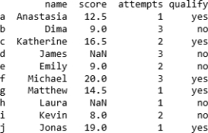

Pandas program to display a summary of the basic information about a specified DataFrame and its data.
Code:
df = pd.DataFrame(exam_data , index=labels)
print("Summary of the basic information about this DataFrame and its data:") print(df.info())

Output:
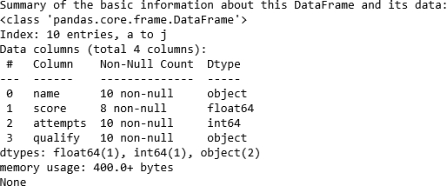

Pandas program to get the first 3 rows of a given DataFrame. Code:
df = pd.DataFrame(exam_data , index=labels) print("First three rows of the data frame:") print(df.iloc[:3])

Output:
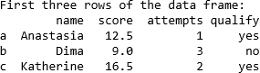

Pandas program to select the 'name' and 'score' columns from the following DataFrame.
Code:
df = pd.DataFrame(exam_data , index=labels) print("Select specific columns:") print(df[['name', 'score']])

Output:
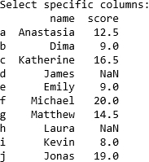

Pandas program to select the rows where the number of attempts in the examination is greater than 2.
Code:
df = pd.DataFrame(exam_data , index=labels)
print("Number of attempts in the examination is greater than 2:") print(df[df['attempts'] > 2])

Output:
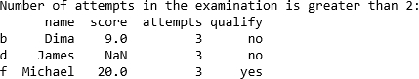

Pandas program to count the number of rows and columns of a DataFrame. Code:
df = pd.DataFrame(exam_data , index=labels) total_rows=len(df.axes[0]) total_cols=len(df.axes[1])
print("Number of Rows: "+str(total_rows)) print("Number of Columns: "+str(total_cols))

Output:
Number of Rows: 10 Number of Columns: 4

Pandas program to select the rows where the score is missing, i.e. is NaN. Code:
df = pd.DataFrame(exam_data , index=labels) print("Rows where score is missing:") print(df[df['score'].isnull()])

Output:

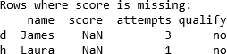

Pandas program to append a new row 'k' to DataFrame with given values for each column. Now delete the new row and return the original data frame. Code:
df = pd.DataFrame(exam_data , index=labels) print("Original rows:")
print(df)
print("\nAppend a new row:") df.loc['k'] = ['Suresh',15.5, 1, 'yes']
print("Print all records after insert a new record:") print(df)
print("\nDelete the new row and display the original rows:") df = df.drop('k')
print(df)

Output:

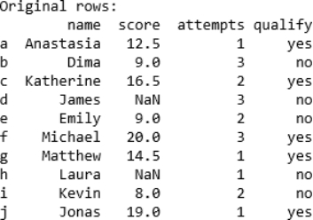

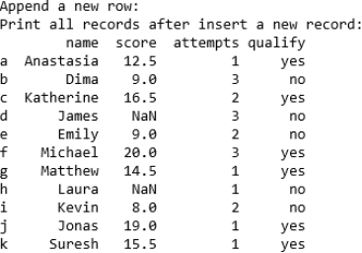

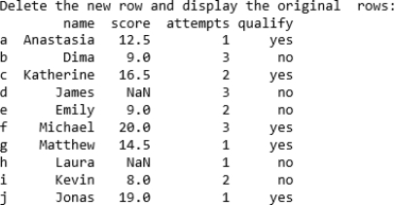

Pandas program to sort the DataFrame first by 'name' in descending order, then by 'score' in ascending order.

Code:
df = pd.DataFrame(exam_data , index=labels) print("Orginal rows:")
print(df)
df.sort_values(by=['name', 'score'], ascending=[False, True])
print("Sort the data frame first by ‘name’ in descending order, then by ‘score’ in ascending order:")
print(df)

Output:
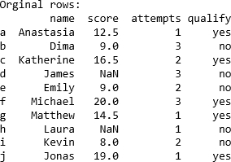

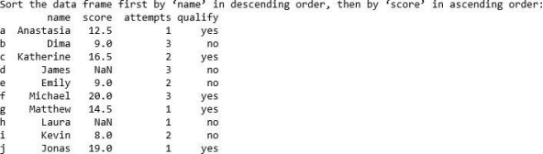

Pandas program to change the name 'James' to 'Suresh' in name column of the data frame.
Code:
df = pd.DataFrame(exam_data , index=labels) print("Original rows:")
print(df)
print("\nChange the name 'James' to ‘Shyam’:") df['name'] = df['name'].replace('James', 'Shyam') print(df)

Output:
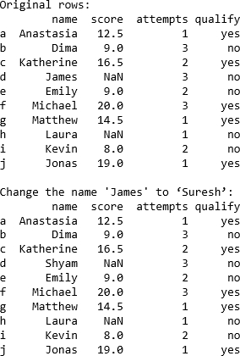

Result:
Thus the working of Pandas dataframe was executed and verified successfully.

